RESOLUTION NO.__________

RE: CERTIFICATE OF APPROPRIATENESS UNDER THE
PROVISIONS OF THE ACT OF THE PENNSYLVANIA
LEGISLATURE 1961, JUNE 13, P.L. 282 (53
SECTION 8004) AND BETHLEHEM ORDINANCE NO.
3952 AS AMENDED.

WHEREAS, it is proposed to install a sign at 711 E. Fourth Street.

NOW, THEREFORE, BE IT RESOLVED by the Council of the City of Bethlehem that a Certificate of Appropriateness is hereby granted for the work.

Sponsored by: (s)

(s)

ADOPTED BY COUNCIL THIS DAY OF

(s)
President of Council

ATTEST:

(s)
City Clerk

HISTORIC CONSERVATION COMMISSION

CASE # 584– It is proposed to install a sign at 711 E. Fourth Street
OWNER/APPLICANT: Louis Calixto/R. Douett

The Commission upon motion by Mr. Hudak seconded by Ms. Starbuck adopted the proposal that City Council issue a Certificate of Appropriateness for the proposed work described herein:
- The proposal to install a sign at 711 E. Fourth Street was represented by Rubyian and Rosean Douett.

- The new sign will be 2’H x 10’W and read “Annie’s Beauty Supply”. The new sign will be installed in the existing box sign and will be made of plastic. The sign may not be internally illuminated.

- The sign will have a simplified background as shown in the sketch provided at the meeting with phone number underneath and a hair dryer, comb, and scissors in the lower left corner.

- There will be a pinstripe around the perimeter. The color of the pinstripe will work with the colors of the sign.

- A revised sign drawing must be sent to City Hall for approval of the final design.
- The proposed motion was unanimously approved.

CU: cu
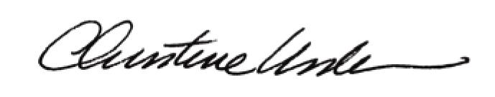

By:

Date of Meeting: March 21, 2016 Title: Historic Officer

